42 38

Name: __________________
Date: __________________

1. Factorize $x^{2}-6x-7$
A. $\left(x+1\right)\left(x+7\right)$
B. $\left(x+1\right)\left(x-7\right)$
C. $\left(x-1\right)\left(x+7\right)$
D. $\left(x-1\right)\left(x-7\right)$
B

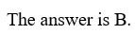

2. Factorize $49p^{2}+9q^{2}-42pq$
A. $\left(7p+3q\right)\left(7p-3q\right)$
B. ${\left(7p+3q\right)}^{2}$
C. ${\left(7p-3q\right)}^{2}$
D. ${\left(49p+9q\right)}^{2}$
C
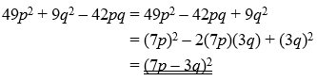

3. Which of the following do(es) not have $x+2$ as a factor?
I. $x^{2}+4$
II. $x^{2}-4$
III. ${\left(x-3\right)}^{2}-25$
A. I only
B. II only
C. I and III only
D. II and III only

A
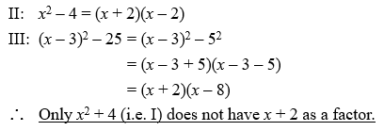

4. Factorize $x^{2}-8xy+15y^{2}-5x+15y$
A. $\left(x-3y\right)\left(x-5y-5\right)$
B. $\left(x-5y\right)\left(x-3y-5\right)$
C. $\left(x+3y\right)\left(x-5y-5\right)$
D. $\left(x+5y\right)\left(x-3y-5\right)$
A
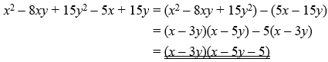

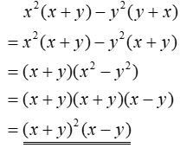
5. Factorize $x^{2}\left(x+y\right)-y^{2}\left(y+x\right)$
A. ${\left(x+y\right)}^{2}\left(x-y\right)$
B. $\left(x+y\right)\left(x^{2}+xy+y^{2}\right)$
C. ${\left(x-y\right)}^{2}\left(x+y\right)$
D. $\left(x-y\right)\left(x^{2}-xy+y^{2}\right)$
A

6. Factorize $y^{2}+4y-12$
A. $\left(y+2\right)\left(y-6\right)$
B. $\left(y+3\right)\left(y-4\right)$
C. $\left(y-2\right)\left(y+6\right)$
D. $\left(y-3\right)\left(y+4\right)$
C

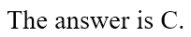

7. Factorize $n^{2}+12n+35$
A. $\left(n+5\right)\left(n+7\right)$
B. $\left(n+5\right)\left(n-7\right)$
C. $\left(n-5\right)\left(n+7\right)$
D. $\left(n-5\right)\left(n-7\right)$
A

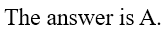

8. Factorize
(a) $x^{2}+8x+7$ (2 marks)
(b) $y^{2}-11y-26$ (2 marks)

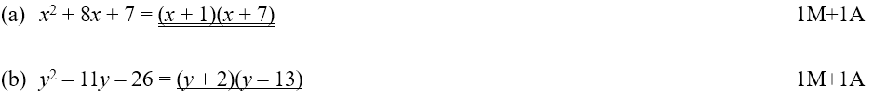

9. (a) Factorize $x^{2}-2xy-35y^{2}$ (2 marks)
(b) Hence, factorize $x^{2}-2xy-35y^{2}-7x+49y$ (3 marks)

$$\left(a\right) x^{2}-2xy-35y^{2}$$
$$=\left(x-7y\right)\left(x+5y\right) 1M+1A$$
$$\left(b\right) x^{2}-2xy-35y^{2}-7x+49y$$
$$=\left(x-7y\right)\left(x+5y\right)-7\left(x-7y\right) 1M$$
$$=\left(x-7y\right)\left(x+5y-7\right) 1M+1A$$

10. Factorize
(a) $240uv-72u^{2}-200v^{2}$ (3 marks)
(b) $63xy^{2}+28xz^{2}+84xyz$ (2 marks)

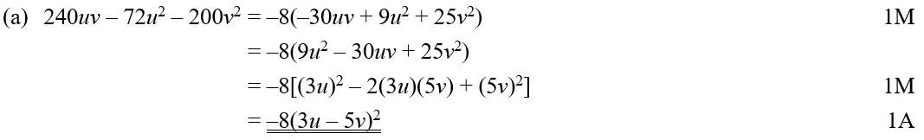
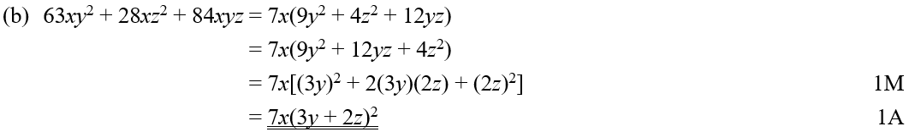

*11. Factorize $a^{4}-a^{2}-2a^{2}b^{2}-2ab+b^{4}-b^{2}$. (7 marks)

